# Final Project

Dear Trainees,

One of the criteria to pass this training program is your shown ability to develop a simple web application.

We provide these screen mockups for you. Your mission is to develop an application and database which will have the functionalities as shown in the mockups using all of the knowledge you have learnt in the training program.

The working product will be assessed separately – you need to put your works in a single folder (properly named) and we will collect it just before you present your project on Tuesday, 2 May 2017.

You also need to present your project. Details on how you need to present it will be informed separately.

# Employee Application

Due to the time limit, you will develop some features of this employee application, which will be detailed in each screen. Login feature is excluded.

**Main screen -** There are search bar, employee list, and employee details. Please disregard the hidden tabs in the details panel.

Keep the icons and user login info on the bar for informational purpose only.

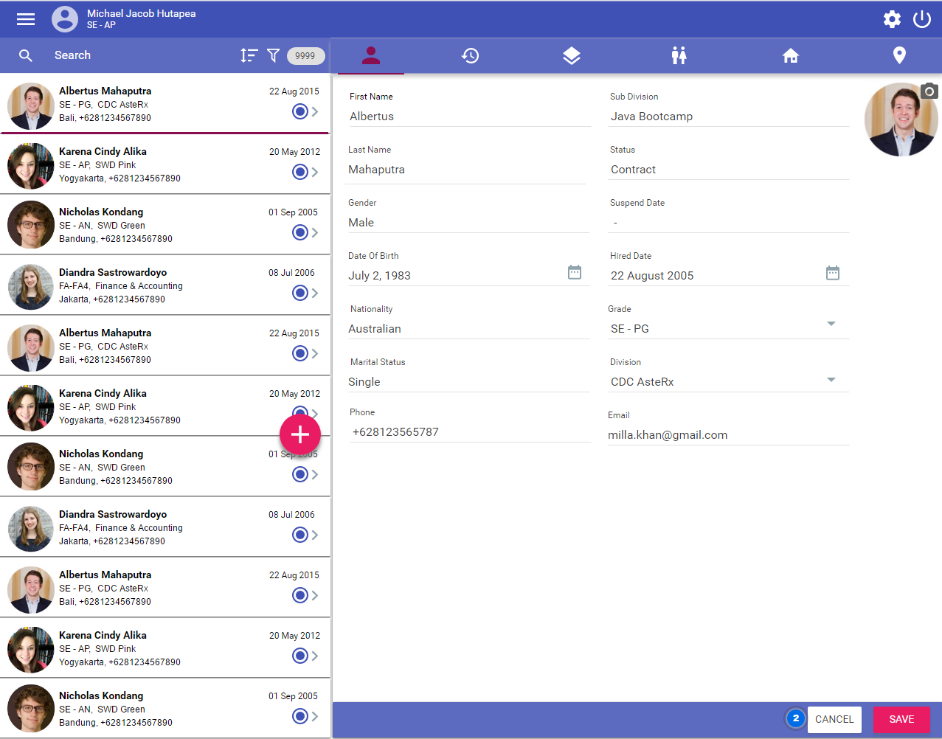

When you click on a card (left hand side – the employee list), the card will be highlighted and a delete icon will be displayed. When the delete icon is clicked, a simple popup dialog will be displayed with OK and Cancel buttons. If OK is clicked, the data will be removed from the view and database. Cancel button should work as commonly expected.

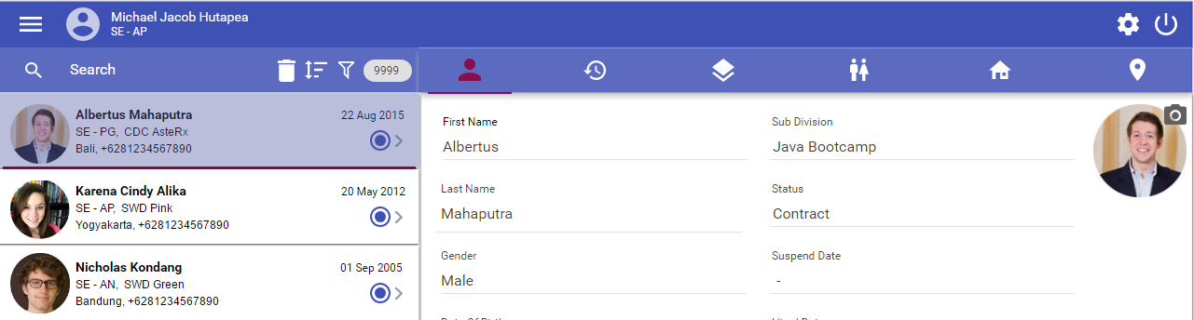

To add a new employee, click on the fab (floating action button) with a plus sign, the employee details will be blank. When the save button is clicked, the data will be saved to the database and the list view (the left hand side) will be updated. Develop the employee detail fields as displayed on the screen, including the ability to upload employee photo. Also, add a new drop down field named Location in the details view. The lookup value is taken from a database table. The other fields hidden in the tabs next to employee detail icon are out of scope.

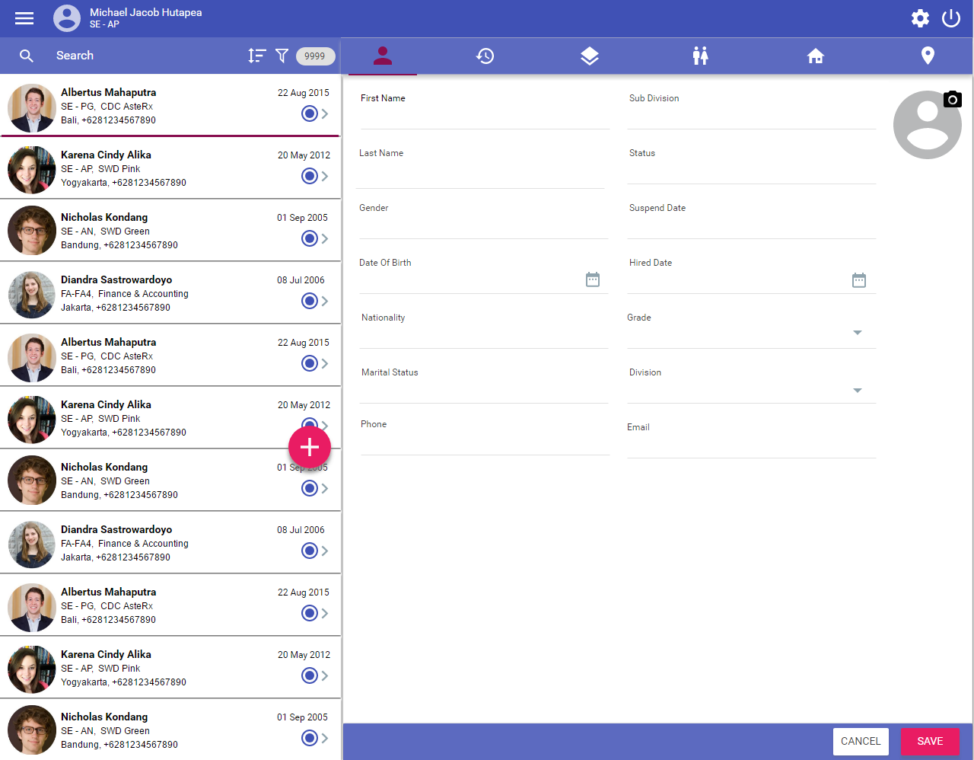

To search an employee, user can type a name in the search bar. The partial match is allowed. The counter shows how many employees found for the given search criteria.

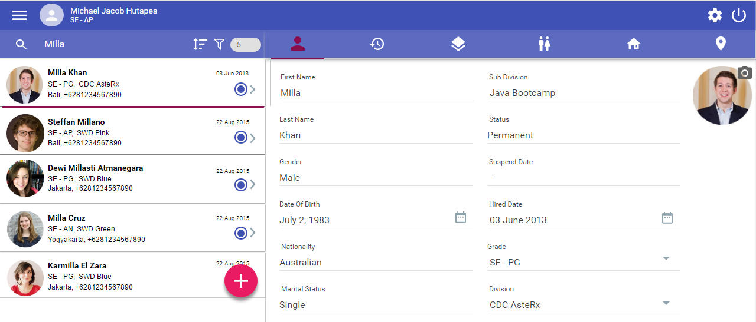

When there is no match, the following screen is displayed.

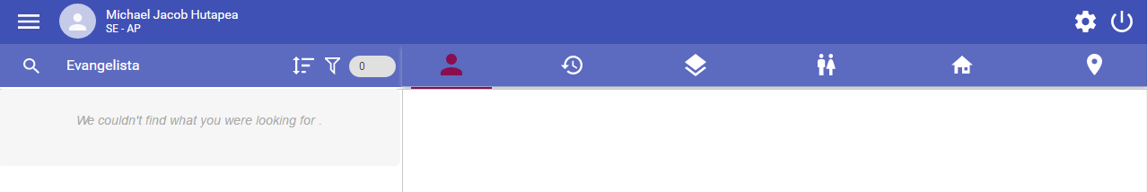

The list can be sorted by clicking on sort button (ascending or descending based on last name).

The filter is used to filter employee based on the location and gender. You can use a simple popup to accommodate this requirement.

Notes:

1. Since you are not expected to develop the login feature, it is assumed that you are logged in and your name should appear at the top of the application
2. The names, Grades, Divisions, etc. can be fictional
3. The pictures may be taken randomly from the Internet
4. There should be at least 12 employees in the database
5. There should be at least 3 employees with similar names, e.g. John Travolta, Johnny Depp, Johnathan Thurston, etc.
6. Other things that are not explained in this document are out of scope – you don’t have to develop them
7. However, if you have extra time, you may develop other features after you have developed all the required features
8. If you have any question at all regarding anything you may answer it yourself based on your good assumption

Assessment criteria:

1. All required features are fully functional
2. Absence of bugs
3. The codes are easy to be maintained, e.g. anyone else can easily understand your codes